

ASSIGNMENT-5
REPORT

Name -Priyam Sharma
Roll No- 2501730184
Course- Btech cse AI/ML
Section-B

“Study Planner with Task Reminder”

This automated system will allow students to input their subjects and assignment deadlines. It will calculate the number of days remaining for submission and automatically prioritize tasks

Algorithm
START
DECLARE subject_name, due_date, current_date, days_left

PRINT "Enter Subject Name"
INPUT subject_name

PRINT "Enter Due Date (Format: DD-MM-YYYY)"
INPUT due_date

GET current_date from System

COMPUTE days_left = due_date - current_date

IF days_left < 0 THEN
PRINT "Status: Deadline Passed!"
ELSE IF days_left <= 2 THEN
PRINT "ALERT: URGENT! " + subject_name + " is due in " + days_left + " days."
ELSE
PRINT "Status: Scheduled. " + subject_name + " is due in " + days_left + " days."
END IF
STOP

Flowchart:
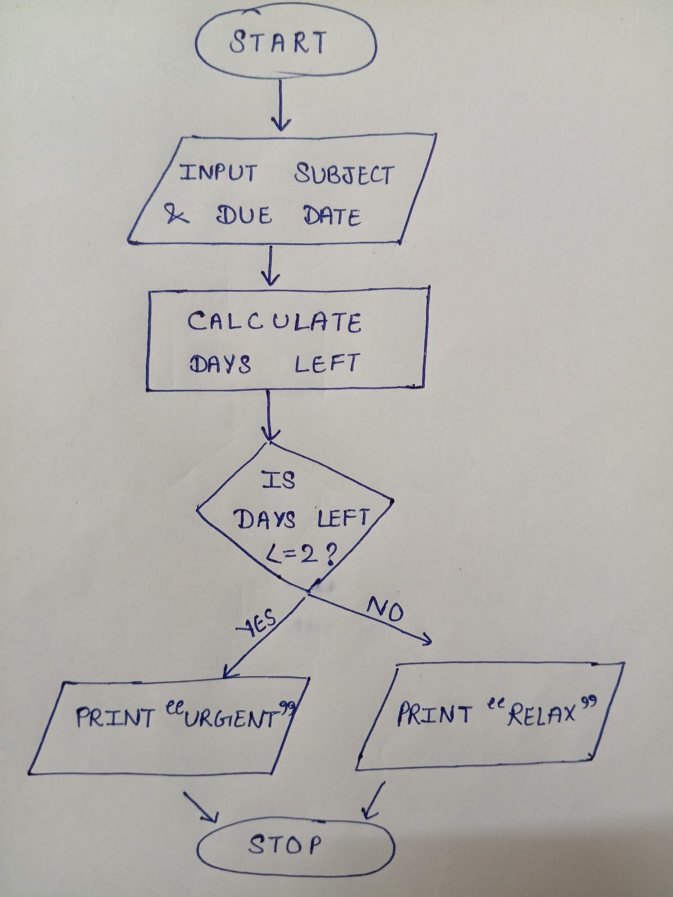

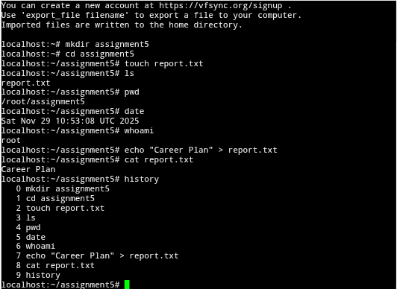
Linux and Automation Practice

Smart goals
1. Short-term (6 months - By June 2026)
Specific: Complete Google AI Essentials certification on Coursera
Measurable: 100% course completion + certificate earned
Achievable: 10 hours total, 2hrs/week alongside semester
Relevant: Builds AI foundation for my specialization
Time-bound: Finish by 30th June 2026
2. Medium-term (2 years - By Dec 2027)
Specific: Build and deploy 3 AI/Robotics projects on GitHub
Measurable: 1) Study Planner app, 2) Object detection robot, 3) Chatbot
Achievable: 1 project/semester using college labs
Relevant: Creates portfolio for internships
Time-bound: All 3 projects live by Dec 2027​
3. Long-term (4 years - By Graduation 2029)
Specific: Secure AI/ML internship at Indian startup
Measurable: 6-month paid internship, ₹30k+/month stipend
Achievable: Apply to 50+ companies via LinkedIn/Internshala
Relevant: Gain industry experience before full-time role
Time-bound: Start internship by June 2029
__________________________________________________
Certifications
1. Google AI Essentials (Coursera)
- Provider: Google
- Duration: 10 hours (self-paced)
- Cost: ₹1,500
- Skills: AI fundamentals, prompt engineering
- Alignment: SMART Goal #1​
2. IBM AI Engineering Professional Certificate
- Provider: IBM/Coursera
- Duration: 6 months (5hrs/week)
- Cost: ₹4,000
- Skills: ML, Deep Learning, Scalable AI
- Alignment: SMART Goal #2 projects

Linkedin updates
Profile link: https://www.linkedin.com/in/priyam-sharma-45a30b381/
Career roadmap
My 4-year B.Tech AI & ML career roadmap begins with ;
Year 1: Foundation and Exploration
Focus: Building the core academic and logical foundation necessary for computer science and data-centric fields.
- Key Academic Areas:
- Basic Programming Principles (C/C++, Python fundamentals).
- Essential Mathematics: Calculus, Linear Algebra, Probability, and Statistics.
- Skill Development:
- Problem-solving and algorithmic thinking.
- Introduction to competitive programming on platforms like GeeksforGeeks.

- Deliverables: Active GitHub profile initiated; participation in university tech clubs.

Year 2: Core CS and Introduction to ML
Focus: Mastering core computer science concepts and transitioning to applied ML fundamentals.
- Key Academic Areas:
  - Data Structures and Algorithms (DSA) – critical for placements.
  - Database Management Systems (DBMS) and Operating Systems (OS).
- Skill Development:
  - Proficiency in Python data stack (Pandas, NumPy, Scikit-learn).
  - SQL proficiency for data handling.
- Projects/Activities: Development of simple ML projects (e.g., linear regression model); participation in initial hackathons.
Year 3: Specialization and Industry Exposure
Focus: Deep specialization in AI/ML sub-domains and mandatory real-world industry experience. This phase is crucial for placement preparation.
- Key Specializations: Deep Learning (CNNs, RNNs), Natural Language Processing (NLP), Computer Vision.
- Skill Development:
  - Proficiency in primary AI frameworks (TensorFlow, PyTorch).
  - Familiarity with Cloud Computing Platforms (AWS, Azure, GCP) and DevOps tools (Git, Docker).
- Experience: Securing and completing a 3-6 month AI/ML internship within the Indian tech ecosystem.
- Deliverables: A robust project portfolio featuring advanced AI applications.
Year 4: Placement and Career Launch
Focus: Finalizing the academic journey, completing a major project, and securing a full-time employment offer.
- Preparation: Intensive revision of DSA and System Design for technical interviews.
- Activities: Active participation in campus placement drives, networking with recruiters on LinkedIn, and refining interview skills.
- Target Roles: Machine Learning Engineer, Data Scientist, AI Engineer, NLP Specialist.

